**Comparison between FxLMS and FuLMS :**

**FxLMS (Filtered Extended Least Mean Squares):** adds an additional learned filter for the secondary path signal - signal from cancellation speakers to users ears

* The idea is to place an identical filter in the reference signal path to the weight

update of the LMS algorithm, which realizes the so-called filtered-X LMS (FXLMS) algorithm.

The Filtered-X LMS algorithm performs the following operations:

* Calculate the output y(n).
* Compute fx(n) by filtering x(n) with the S^(z) estimate.
* Update the filter coefficients using an LMS equation.

To summarize, the input signals to a Filtered-X adaptive filter are x(n) and e(n). Input x(n) is the synthesized reference signal produced by the sum of the measured error e(n) and the secondary signal y(n) filtered by the secondary path estimate, i.e., X(z) = E(z) + S(z)Y(z).

**Advantages**

* This algorithm appears to be very tolerant to errors made in the estimation of S(z) thereby allowing offline estimation of S(z) as the most apt choice.
* The use of FIR filters to design W(z) makes this system very stable.
* The convergence rate of algorithm depends on the accuracy of the estimation of S(z).

**Disadvantages**

* The major disadvantage of this algorithm is the presence of acoustic feedback. The coupling of the acoustic wave from the cancelling loudspeaker to the reference microphone will cause this acoustic feedback problem, resulting in a corrupted reference signal x(n).
* This can potentially lead to delayed convergence and possible non-convergence of the algorithm.

The rate of convergence of the algorithm increases with the filter order and with larger step sizes

**Flowchart of FxLMS:**

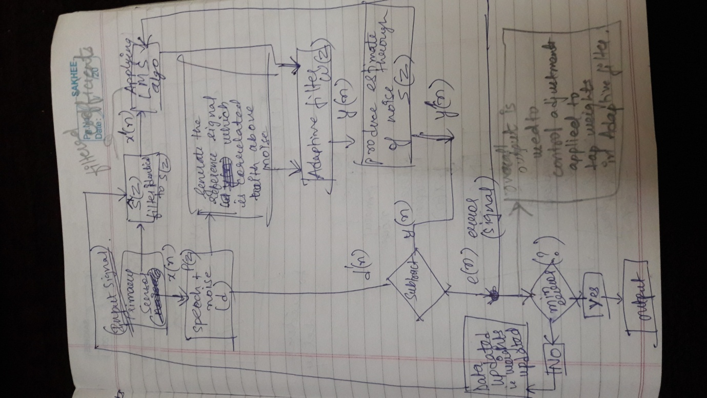

**FuLMS (Filtered-u Last Mean Squares):** adds an additional active LMS filter to FxLMS to cancel out noise bleeding from the cancellation speaker to the error mic.

* The simplest approach to solving the acoustic feedback problem is to use a

separate feedback cancellation, or “neutralization,” filter within the controller.

* When feedback is present, the optimal solution of the adaptive filter is generally an IIR function with poles and zeros. The poles of an IIR filter make it possible to obtain well-matched characteristics with a lower order structure, thus requiring fewer arithmetic operations.
* the disadvantages of adaptive IIR filters are: IIR filters are not unconditionally stable; the adaptation may converge to a local minimum; and the IIR adaptive algorithms can have a relatively slow convergence rate in comparison with that of FIR filters.

**Advantages**

* FULMS algorithm converges faster than the FxLMS algorithm.
* Also unlike FxLMS, here global convergence is not assured

**Flowchart of FuLMS:**

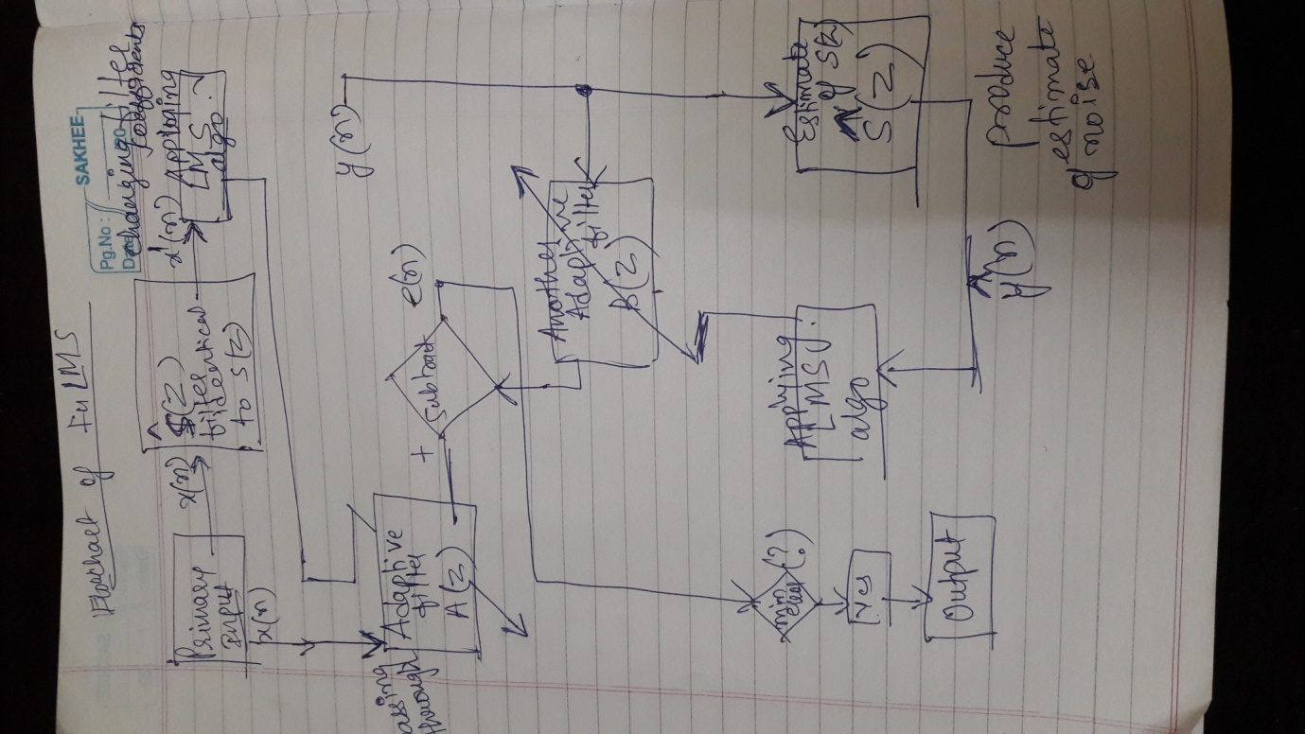

|  |  |  |
| --- | --- | --- |
| Algorithm | FxLMS | FuLMS |
| Definition | In addition to LMS  the input to the error correlator is filtered by a secondary-path estimate.This results in the filtered-X LMS . | Filtered-u LMS Algorithm for ANC tries to adapt coefficients of an infinite impulse response filter |
| Stability | Stable compared to FuLMS | Less Stable |
| Convergence | Slow convergence speed | Good convergence speed |